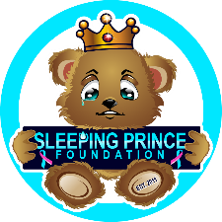

Sleeping Prince Foundation Inc.
P.O. Box 561002
The Colony, TX 75056
sleepingprincefoundation@gmail.com

Thank you so much for your participation in the 9th Annual Sleeping Prince Foundation Toy and Clothing Drive. Please see the guidelines and suggested list below:
Since these babies are in the intensive care unit all items must be New.

Please send all donations to:
P.O. Box 561002
The Colony, TX 75056

You can also donate via Paypal and Zelle using “sleepingprincefoundation@gmail.com”
and we will shop for you.

Suggested Items:
- Clothing:
- Preemie -0-3 Months Clothes for Boys or Girls
- My 1st Christmas Onesie / booties
- Blankets:
- Receiving blankets (only)
- Blankets:
- Toys:
- Crib Mobiles
- Soft Books
- Rattles
- All toys are welcomed
- Necessities:
- Pacifiers
- Baby bags

If you would like to donate in memory of your sleeping baby or a friend, relative please complete the attached form and return with your donation to the above PO Box or via email to sleepingprincefoundation@gmail.com

Donation in Memory Information Form:

Name: ______________________________________________________
Date of Birth: ________________________________________________
Date of Death: ________________________________________________
Additional Comments: __________________________
“I will lie down and sleep in peace” – Psalms 4:8
In Loving Memory of Prince Charles Jeremiah Spencer 11-26-11

With Kind Regards,

Charmin Spencer
Charmin Spencer
Founder

